There are 8 types of Questions will be there

1 Select Necessary Column name of all the fields

2 Define First left table

3 Type of join want to perform

4 Define the right table

5 On Condition (Connectivity between two table)

Optional steps

6 Where condition

7 Group by (Aggregate statement)

8 orders by statement

But when in cross join 5th step is illumined.

Connect the relevancy

Inner JOIN

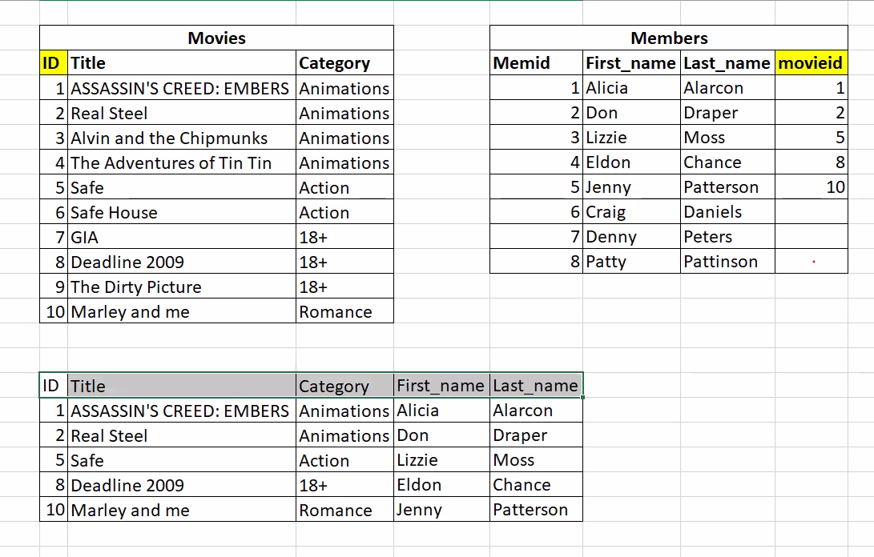

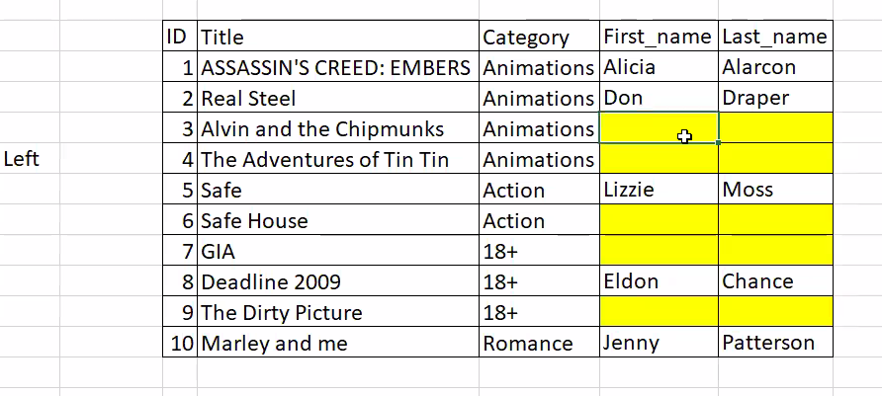

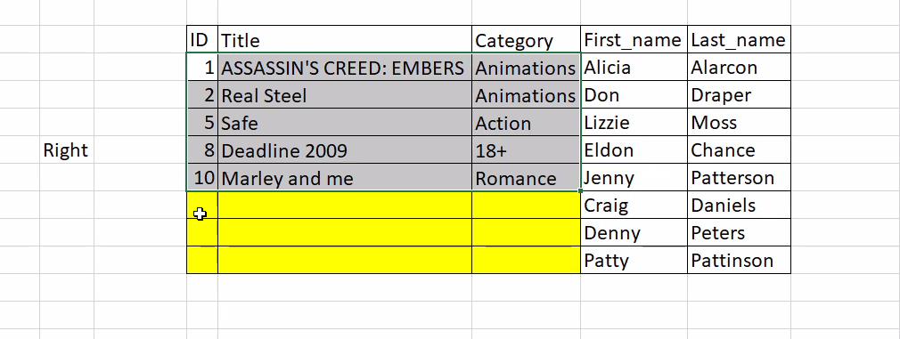

Cartition product

Selft Join

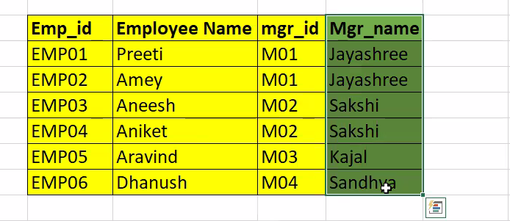

Camguas error

